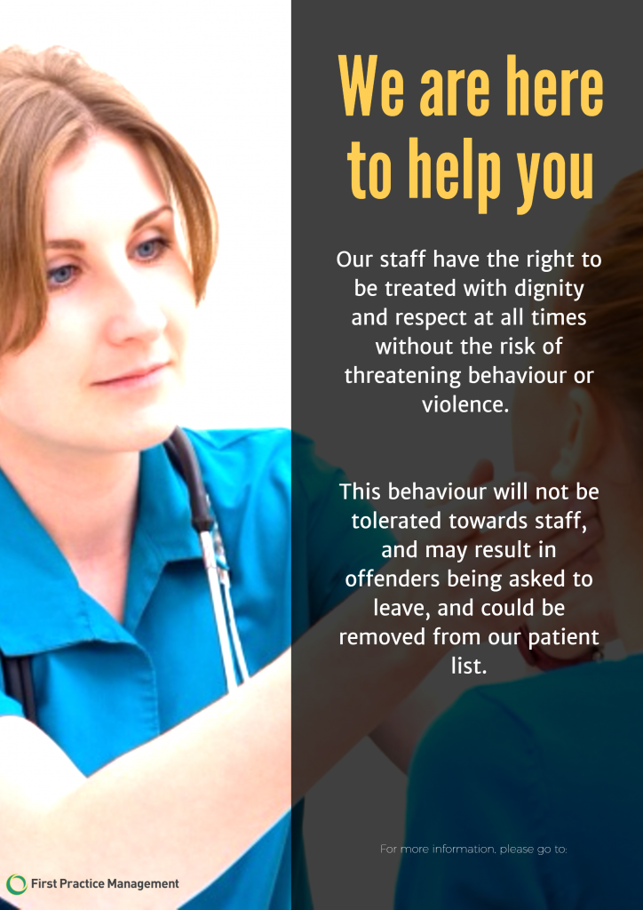
NOTE TO PATIENTS
Throughout 2021 the aggression and rudeness towards our Reception team has reached an unacceptable level and the Partners must consider the Health & Wellbeing of its staff.
In recent weeks the Receptionist dealt with 1800 telephone calls in one day and the practice could certainly not function without them.
Please note that Len Valley Practice will not tolerate any aggression towards its staff and if needed will be speaking to these patients directly.

